ABIRAMI K

230701008 CSE-A

EXP 5 SYSTEM CALLS

PROGRAM:

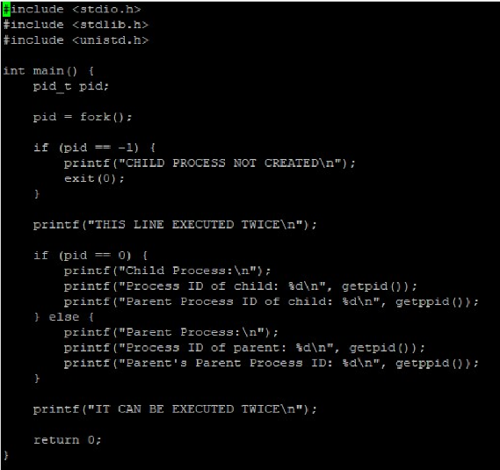

OUTPUT:

